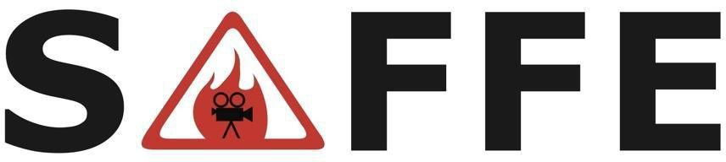
Safety Advisory for Fire & FX in Entertainment
When: 9:00 AM, Thursday, June 27, 2024 Location: Burbank Fire Department Training Center
1845 N. Ontario Street Burbank, CA. 91505

Parking: Off of Ontario Street, South side of Training Center next to Schafer Field.
After parking, follow SAFFE signs to Training Center Classroom.

Hosted by: Burbank Fire Department
Tray White, Battalion Chief Ryan Weber, Captain

AGENDA
- 0900 - Welcome/Logistics by Burbank Fire Department
- 0905 - Self Introductions
- 0915 - Administrative Business - Rich Momii
- 0920 - Current State
  - State Fire Marshal
  - Pyrotechnics Training
  - California Film Commission

- 0930 - New Business & Updates
  - Future Meetings
  - Contract Services
  - Film LA
  - Studios: Amazon, Apple, Disney, MBS, NBC, Netflix, Paramount, Sony, WB

- 1015 - Break

- IATSE
- ASEPO
- Firearms
- Stunts
- Fire Performers
- Fire Departments

- 1030 - Training: “Flame Retardant Chemicals & Fabrics” Patricia Setter, CAL FIRE/OSFM Program Coordinator

- 1140 - Round Table
- 1200 - Adjournment

PLEASE RSVP for security and logistical purposes to Rich Momii at: rgmomii@yahoo.com

Website: www.safefirefx.org

