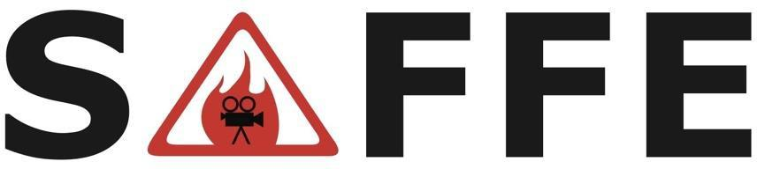
Safety Advisory for Fire & FX in Entertainment

When: 9:00 AM, Wednesday, December 11, 2024

Location: NBC Universal
3900 Lankershim Blvd.
Universal City, CA 91608

Parking: Gate 2 (James Stewart Ave)
After parking, follow SAFFE signs to Building 2160

Hosted by: NBC Universal
Jeff Egan, VP Production Safety
Chris Schiel, Senior Manager, Production Safety

AGENDA
- 0900 - Welcome/Logistics by NBC Universal

- 0905 - Self Introductions

- 0915 - Training: EODev Hydrogen Fuel Cell Power Generator System Steven De Santis, VP, Americas EODev

- 1030 - Break

- 1045 - Current State
- State Fire Marshal
- Pyrotechnics Training
- California Film Commission

- 1100 - New Business & Updates

- Future Meetings
- Contract Services
- Film LA
- Studios: Amazon, Apple, Disney, MBS, NBC, Netflix, Paramount, Sony, WB
- IATSE
- ASEPO
- Firearms
- Stunts
- Fire Performers
- Fire Departments

- 1145 - Holiday Cheer Round Table

- 1200 - Adjournment
PLEASE RSVP for security and logistical purposes to Rich Momii at: rgmomii@yahoo.com

Website: www.safefirefx.org

